UNHELPFUL THINKING PATTERNS

________________________________________________________
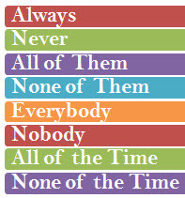
Black & White
If I’m not perfect I have failed
Either I do it right, or not at all

Imperfection can still equal success – forgetting an item on a grocery list does not mean the trip was a complete bust.
_____________________________________________________
Mental Filter
Focusing on a critical comment while ignoring all the compliments you’ve received.

Only paying attention to certain types of evidence & dismissing anything that doesn’t ‘fit.’ Noticing failures and not seeing successes.
________________________________________________________
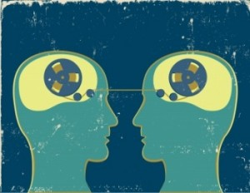
Mind reading
An acquaintance seems less friendly than usual – “he must be angry with me.”

Thinking you know what others are thinking / how they feel about you.
________________________________________________________
Fortune Telling
Before going to a social gathering you have an image of people reacting negatively to you and you assume that you will be devastated.

Predicting that things will turn out badly and you will not be able to cope.
________________________________________________________
Emotional Reasoning
I feel anxious so I must be in danger. I feel embarrassed so I must be an idiot.

Assuming that how you feel is an accurate reflection of how things are. Feelings are simply a reaction to thoughts.
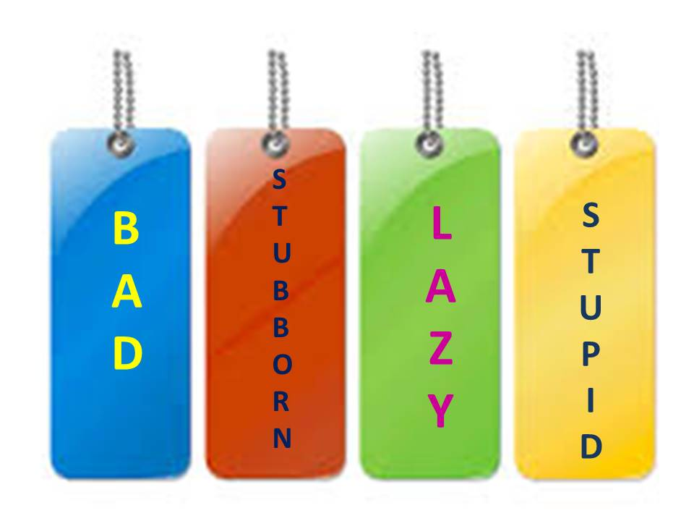
________________________________________________________
Labeling
An extreme form of all-or-nothing thinking which can be damaging to our self esteem and relationships.

________________________________________________________
Overgeneralizing
Nothing good ever happens.

Seeing a pattern based upon a single event or being overly broad in the conclusions we draw.
_______________________________________________________
Disqualifying the Positive

Oh that? That doesn’t matter, that was nothing.

Discounting the good things that have happened.

________________________________________________________
Catastrophizing / (Magnification)
What if….the worst??

You expect, even visualize disaster. Imagining and believing that the worst possible thing will happen.
________________________________________________________
Should & Must
Often leads to feelings of guilt. Language implies that we have already failed. Adds pressure and unrealistic expectations. You have a list of ironclad rules about how you and other people ‘should’ act. Anger and guilt appear when the rules of your making have been violated.
________________________________________________________
Personalization
The same person who noticed the acquaintance was not being as friendly as usual thinks, “I must have done something wrong.”

Blaming yourself or taking responsibility for something that wasn’t entirely under your control. You assume that everything people do or say is some kind of reaction to you. Comparing yourself to others comes in here.

